Operations Report

Mr. Analytiks:

Please see the below report to assist in your decisions moving forward.

The first problem you have asked me to solve involved site selection. For this problem, I have used a Fixed-Charge Model to discover which of the three potential sites to build, which will minimize your costs. I will attach a picture of my model and explain from there.

This model takes into account the shipping, variable, and fixed costs. So we set our objective function in this model to :

Minimize: Transportation Costs(T11 + T12+ T13 +T21 + T22 + T23 + T31 + T32 + T33 + T41 + T42 + T43 + T51 + T 52 + T53 + T61 + T62 + T63 + T71 + T72 + T73 + T81 + T82 + T83) + Fixed Costs (F1 + F2 + F3 + F4 +F5 + F6 + F7 + F8) + Variable Costs (V1 + V2 + V3 + V4 + V5 + V6 + V7 + V8)

Reference:

T11 = Transportation costs of Plant 1 shipping to Distribution Center 1 ( $36* Plant 1 Production shipped to DC1)

F1 = Fixed cost of Plant 1 (10,000 * 1) Since this plant is existing, we multiply it by 1 to show that we have incurred cost here. For example, F7 will be 0 because $9,500 * 0 = 0, since our LP Model determined not to build this.

V1 = Variable cost * Units produced in Plant 1 ( Flow out of Plant 1 * Given Variable costs $15)

We are subject to the following constraints:

Build Constraints:

Number of potential plants to build <= 3

All of these values must be Binary.

Capacity constraints:

Plant 1 Production: DC1 + DC2 + DC3 <= 490000

Plant 2 Production: DC1 + DC2 + DC3 <= 410000

Plant 3 Production: DC1 + DC2 + DC3 <= 485000

Plant 4 Production: DC1 + DC2 + DC3<= 582000

Plant 5 Production: DC1 + DC2 + DC3 <= 585000

Plant 6 Production: DC1 + DC2 + DC3 <= 675000

Plant 7 Production: DC1 + DC2 + DC3<= 643000

Plant 8 Production: DC1 + DC2 + DC3 <= 552500

Demand constraints:

Distribution Center 1: P1 + P2 + P3 + P4 + P5 + P6 + P7 + P8 >= 995000 * Demand Fluctuation

Distribution Center 2: P1 + P2 + P3 + P4 + P5 + P6 + P7 + P8 >=895000 * Demand Fluctuation

Distribution Center 3: P1 + P2 + P3 + P4 + P5 + P6 + P7 + P8 >=840000 * Demand Fluctuation

With P1 being Plant 1 Production

As you can see in our model, we have added a demand fluctuation that is very easy to use. Based on the demand, it also changes our suggested sites to build. Our above model is shown with the forecasted demand that you have given us, which suggests that Plants 5, 6, and 8 be built, with an estimated costs of $70,184,325.00.

If we factor in a 15% increase we get the same build suggestions with a total cost of $82,471,575.00, as you can see in the below model.

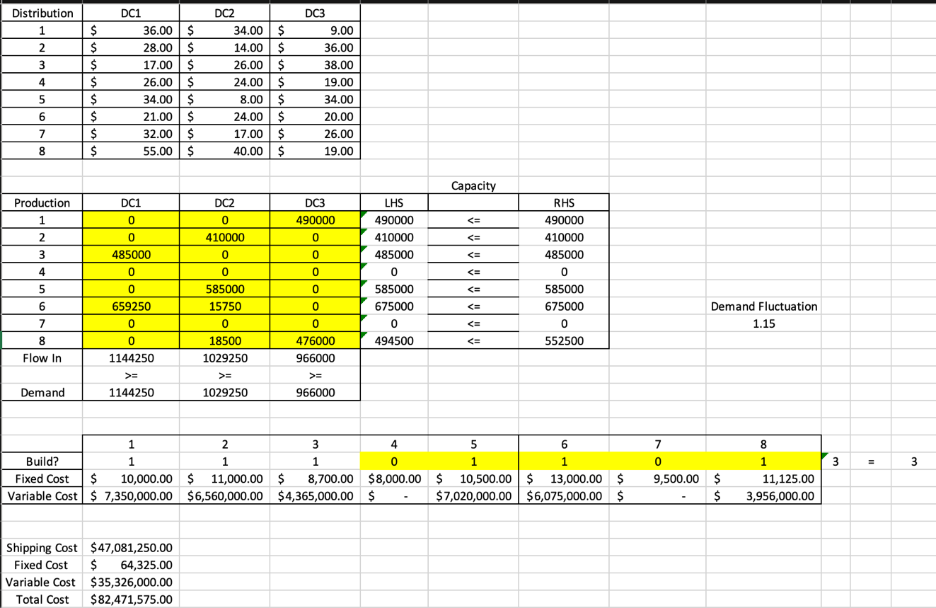

When we account for a 20% increase, our suggested sites move to 5,6,7 with a total cost of $94,643,700.00.

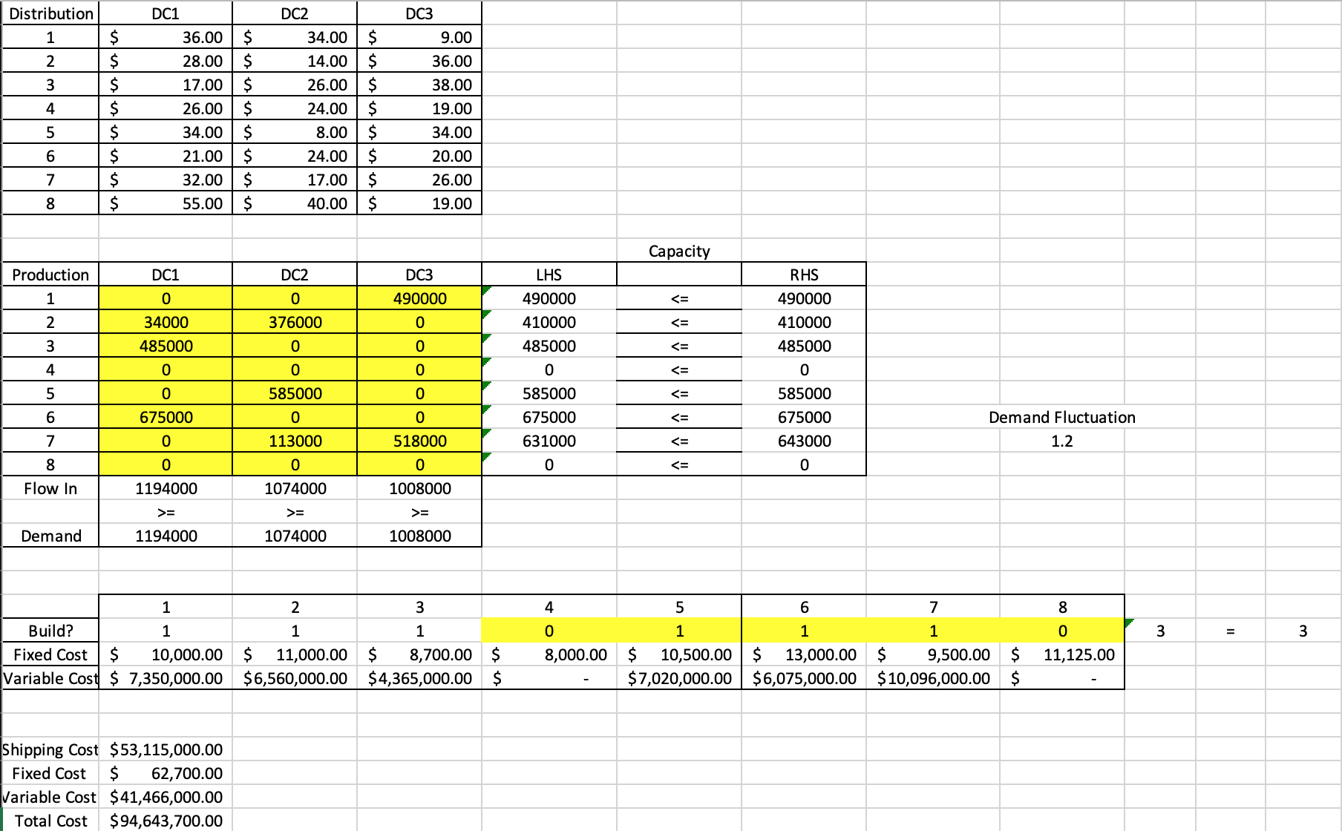

Conclusion:

When taking long term demand increase into consideration, it seems that Plant 5, Plant 6, and Plant 7 must be built. While it may not be ideal in the short term, this will allow for minimizing costs long-term.

HR Planning:

Our next objective is to optimize your Inventory and Employee costs as to not have to Hire and Fire on a monthly basis. I have created a Multi-Period production plan which should help fulfill your needs. It is as follows:

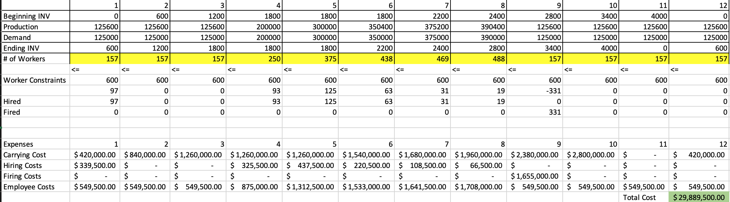

This model takes into account: Carrying Costs, Hiring Costs, Firing Costs, and Employee Retention Costs.

Our Objective Function is as follows:

Minimize: Carrying Cost (CC1 + CC2 + CC3 + CC4 + CC5 + CC^ + CC7 + CC8 + CC9 + CC10 + CC11 + CC12) + Hiring Cost (HC1 + HC2 + HC3 + HC4 + HC5 + HC6 + HC7 + HC8 + HC9 + HC10 + HC11 + HC12) + Firing Cost (FC1 + FC2 + FC3 + FC4 + FC5 + FC6 + FC7 + FC8 + FC9 + FC10 + FC11 + FC12) + Employee Costs(EC1 + EC2 + EC3 + EC4 + EC5 + EC6 + EC7 + EC8 + EC9 + EC10 + EC11 + EC12)

Reference:

Production = # of Workers * 800

Beginning INV = Ending INV of previous Period.

Demand = Demand DC1 + Demand DC2 + Demand DC3 for given period.

CC1 = Carrying Cost of Period 1 (Ending inventory * $700)

HC2 = Hiring Costs of Period 2 (# of Workers Period 2 – # of Workers Period 1(If result is positive) * $3500)

FC2 = Firing Cost of Period 2 (# of Workers Period 2 – # of Workers Period 1 (If result is negative * -1) * $5000)

EC3 = Employee Cost of Period 3 (# of Workers * 35000)

Production Constraints:

Ending Inventory >= 0

# of Workers = Integer

Period 1 Production >= Period 1 Demand

Period 2 Production >= Period 2 Demand

Period 3 Production >= Period 3 Demand

Period 4 Production >= Period 4 Demand

Period 5 Production >= Period 5 Demand

Period 6 Production >= Period 6 Demand

Period 7 Production >= Period 7 Demand

Period 8 Production >= Period 8 Demand

Period 9 Production >= Period 9 Demand

Period 10 Production >= Period 10 Demand

Period 11 Production >= Period 11 Demand

Period 12 Production >= Period 12 Demand

Employee Capacity Constraints:

6 plants at a capacity of 100 each

Period 1 Employees <= 600

Period 2 Employees <= 600

Period 3 Employees <= 600

Period 4 Employees <= 600

Period 5 Employees <= 600

Period 6 Employees <= 600

Period 7 Employees <= 600

Period 8 Employees <= 600

Period 9 Employees <= 600

Period 10 Employees <= 600

Period 11 Employees <= 600

Period 12 Employees <= 600

Conclusion:

As a result of our model, we can see the optimal number of workers per period, which will allow for the least amount of carrying costs and associated employee costs. While there will still be hiring and firing costs associated, this will allow for 6 months of regular production, and then a hiring of temp workers for the busier Periods 4-8, and once these temporary contracts are up, we can go back to normal production. Since we start with only 60 workers, there is an initial hiring costs, but once this model is in place, we should be going into the new year with the optimal number of worker which will prevent us from having to start the next year with hiring costs. This will end the constant hiring and firings, and will instead cut them down to half of the year. The estimated cost of Production will be $29,889,500.00.